Title length is not more than 12 words, and it should be clear, brief and informative. Abbreviation, formula, year, and place should be avoided

Author^{1}, Author², Author³, Author⁴, Author⁵, Author⁶
^{1,2,3,4}Faculty of…., University, Country
^{5,6}Faculty of…., University, Country

Corresponding Email:
Abstract. Abstract should be written briefly and factually (no more than 250 words). Abstract contains of the clear elaboration of research purpose, result and conclusion. Abstract should be written separately from the article. Reference should not be written in abstract, but if it is indispensable, authors’ name and publication year should be cited. Non standard abbreviation should be avoided, but if it is indispensable, the full name should be specified in its initial mention. The word length is not more than 200 words, written in English.
Keywords: must be 3- 5 words or phrases

- Introduction
The introduction contains the purpose of article that is formulated and presented by an adequate background. The introduction must cover urgency, supporting facts from previous studies, gap analysis, status, research novelty, and research objective. The gap analysis means the gap found within the prior research, while the research status is the posi-tion towards previous studies whether it corrects, debates, or supports. The references must be taken from various Scopus or WoS indexed-journals published not later than 10 years from the article submission

- Method
Method used should be accompanied by references, relevant modification should be explained. Procedure and data analysis techniques should be emphasized to literature review article. The research stages should be clearly stated.

- Result and Discussion
The results and discussion should be presented in the same part, clearly and briefly. The discussion part should contain the benefit of research result, not repeat result part. The research results could be supplemented with tables, figures, or graphs (separate writing terms) to clarify the discussion. Avoid presenting similar data in a separate table. The analysis should answer the gap stated. The qualitative data, e.g. interview results, is discussed in paragraphs. The references contained in the introduction should not be re-written in the discussion. A comparison to the previous studies should be presented.

The Example of Table
Table 1. Title
Title | Title | Title
Content | Content | Content
Content | Content | Content
Content | Content | Content
Content | Content | Content

The Example of Figure
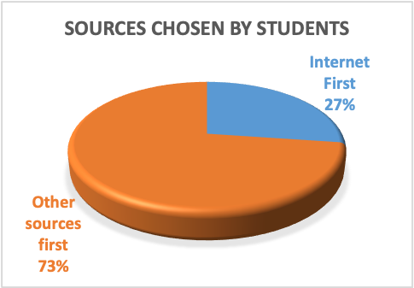
Figure 1. Title

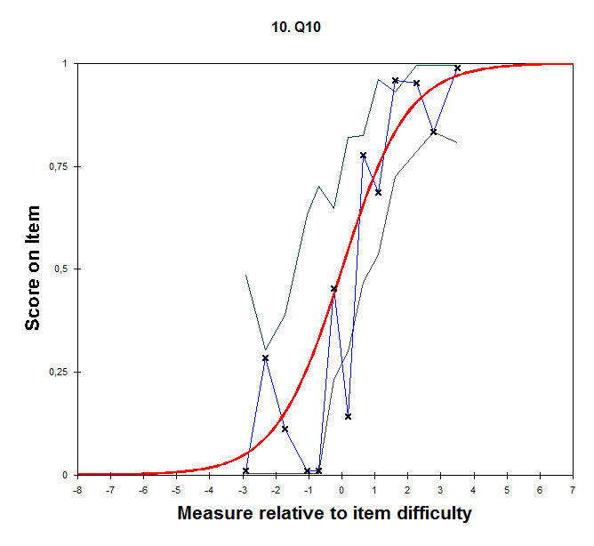
Figure 2. Title

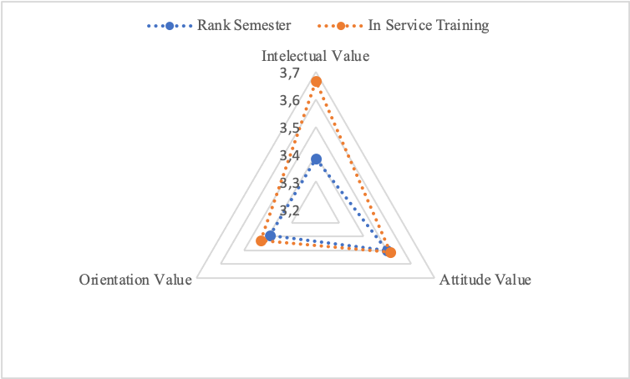
Figure 3. Title

- Conclusion
Conclusion is presented briefly, narrative and conceptual which describes the research findings and its impacts. Please avoid using bullets.

- References
List the references in alphabetical order and chronologically. Bibliography is a non-bibliographic list of references/references, so it must contain all sources referred to in the manuscript, and does not need to contain sources that are not referred to. The reference list contains everything referred to in the text that comes from sources that are; (a) relevant, (b) at least 80% recent (last 10 years), and (c) at least 80% primary. Writing references refers to the American Psychological Association (APA) 6Ed and uses the Mendeley application

Example Reference:
Baddeley, A. (2012). Working memory: theories, models, and controversies. Annual Review of Psychology, 63, 1–29. http://doi.org/10.1146/annurev-psych-120710-100422.
Kashefi, H., Ismail, Z., & Yusof, Y. M. (2010). Obstacles in the learning of two-variable functions through mathematical thinking approach. Procedia - Social and Behavioral Sciences, 8(5), 173–180. http://doi.org/10.1016/j.sbspro.2010.12.024.
Prayitno, H. J., Kusmanto, H., Nasucha, Y., Rahmawati, L.E., Jamaluddin, N., Samsudin., & Ilma, A.A. (2019). The Politeness Comments on The Indonesian President Jokowi Instagram Official Account Viewed From Politico Pragmatics and The Character Education Orientation in The Disruption Era. IJOLAE: Indonesian Journal on Learning and Advanced Education, 1(2), 52–71.

